Team name: First name Last name, First name Last name, First name Last name

<Project Title>

**Project Report**

First-year Hardware Project

School of ICT

Metropolia University of Applied Sciences

22 March 2023

Abstract

Instructions (REMOVE WHEN READY): The abstract is a brief summary of the complete project report. It includes a brief introduction of your **topic**, **methods**, project work, **results**, and conclusions. The abstract is the first part of the report but typically written last. A suitable length for the abstract is half a page to one page.

The meaning of the abstract is to give a reader an overall view of your research/project. After reading the abstract, the reader can also decide if they should read the rest of the report.

Write the abstract in past tense. If you can summarize the whole project, it has already been finished. Do not introduce any new material in the abstract.

**Version history**

|  |  |  |  |
| --- | --- | --- | --- |
| **Ver** | **Description** | **Date** | **Author(s)** |
| 1.0 | Created structure for the project report. Added instructions for what should be included in the different parts of the document. | 13.3.2023 | Saana Vallius |
| 1.1 | Added Instructions (REMOVE WHEN READY), minor editions. | 14.3.2023 | Sakari Lukkarinen |
| 1.2 | Highlighted all instructions with red font. | 19.3.2023 | Sakari Lukkarinen |
| 1.3 | Updated Appendix 2 based on comments. Updated table of contents. | 22.3.2023 | Saana Vallius |
| 2.0 | Added a section for group work summary. Changed the highlighted instructions to an easier color to handle. | 22.10.2023 | Saana Vallius |
|  |  |  |  |
|  |  |  |  |
|  |  |  |  |
|  |  |  |  |

Contents

1 Introduction 1

2 Theoretical Background 1

3 Methods and Material 2

4 Implementation 2

5 Group Work Summary 3

5.1 Midway Summary 3

5.2 Final Summary 3

6 Conclusions 4

References 5

Appendices

Appendix 1: Introducing Figures and Other Items

Appendix 2: Using Appendices

# Introduction

Instructions (REMOVE WHEN READY): This document is a report template for the first-year hardware project on the Hardware 2 course. A suitable length for the report is 10-15 pages. Use figures, tables, and other visual elements to help the reader understand your project.

This template introduces the basic structure for the report, including what information should be included in different parts of the report. The purpose of the template is to guide in writing the report, but the structure and headings of your report do not have to match the template exactly. Appendix 1 contains instructions for introducing figures and other visual items in your report. Appendix 2 explains how appendices are used.

The aim in the introduction section of the report is to introduce the topic, goals, and motivation for the project. Moreover, the goal is to get the reader interested in your work. In the introduction, you should also mention the name of the course the project is done on.

The introduction should answer the following questions:

1. What is the topic of your project?
2. What is your project trying to solve?
3. Why are you doing the project?
4. What are the goals for the project?

# Theoretical Background

Instructions (REMOVE WHEN READY): The goal for the background section is to provide enough background information about the project so that a reader with reasonable technical knowledge understands what your project is about, even if they do not have specific knowledge about the phenomena behind the project.

In this section you should introduce the physiology related to heart rate measurements. Furthermore, you should introduce the sensor used in the project and the operating principle of the sensor. You should base your background research on high-quality references.

The Background section should answer the following questions:

* What are heart rate and heart rate variability (HRV)? In what units are they measured?
* What physiological phenomena are associated with heart rate and HRV?
* What are the typical values or minimum and maximum rates for the measurements? Is the range of values the same for everyone?
* What kind of a signal does the sensor used in the project produce? How can it be used for measuring heart rate or HRV?

# Methods and Material

Instructions (REMOVE WHEN READY): This section discusses how the project was carried out. Introduce the materials used in the project: the sensor, software, devices, and their most important technical properties. Furthermore, you should discuss how you tested the system and verified that it produces valid readings for the measured parameters.

Note: You should not discuss the implemented system or any results from your measurements in this section.

# Implementation

Instructions (REMOVE WHEN READY): This section discusses the final system your team developed during the project. In this section you must describe the finished system as well as the algorithms you developed for the heart rate and HRV measurements. This section must also include a system diagram. Explain what happens in each part of the system.

Include the following:

* System: The final end-to-end system, including devices and connections.
* Algorithms: The developed algorithms used for calculating heart rate and heart rate variability.
* Data: How much data was collected and for how long? Where and how was the data processed?

# Group Work Summary

Instructions (REMOVE WHEN READY): In this section you will write a summary of what each group member has done in the project. You will write two summaries: One midway through the project and another at the end of the project. Each group member should write their own part in the summaries.

## Midway Summary

Write this summary of your group work midway through the project. The summary should include the following:

* The name of each group member with a short summary of what they have done towards completing the project so far.
  + The contribution can for example relate to:
    - Programming
    - Background research
    - Writing the project report
* The plans for the next weeks until the end of the project.
* Any problems or blockers you have encountered so far in your project.

## Final Summary

Write this summary of your group work at the end of the project. The summary should include the following:

* The name of each group member with a short summary of what they have done towards completing the project so far.
  + The contribution can for example relate to:
    - Programming
    - Background research
    - Writing the project report
    - Preparing the project presentation
* An evaluation of the overall performance of your group during the project.

# Conclusions

Instructions (REMOVE WHEN READY): In the conclusions section, you should wrap up the report and evaluate how well the original goals of the project were achieved.

The section should answer the following questions:

1. How well did the project go?
2. Were the goals reached?
3. What kind of problems occurred during the project? How did you handle them?
4. What limitations does your prototype measurement system have?
5. How could the work be improved or continued in the future?

References

Instructions (REMOVE WHEN READY): Use one of the referencing systems below. Remove the one that you do not use.

Harvard (author-date) system:

The reference list entries need to be in alphabetical order according to the last name of the author mentioned first in the list of authors.

Davies, Barbara; Jameson, Peter & Smith, John. 2013. Advanced economics. Oxford: Oxford University Press.

Mitchell, John Arnold & Thomson, Magdalena. 2017. A guide to citation. London: London Publishings.

Vancouver (numbering) system:

1. Mitchell, John Arnold & Thomson, Magdalena. 2017. A guide to citation. London: London Publishings.
2. Davies, Barbara; Jameson, Peter & Smith, John. 2013. Advanced economics. Oxford: Oxford University Press.

Introducing Figures and Other Items

Add figures, graphs, diagrams, code snippets, equations, tables, and other items into your text to make it more interesting and clearer to read.

All items must be **introduced** in the text. This includes appendices.

* If you cannot explain an item in the text, it probably should not be there.
* A good rule of thumb is to:
  + first introduce the item by its number
  + then present the item
  + lastly, tell the reader what they should pay attention to when examining the item. Explain or interpret the item.
* Each item must have a **caption** and be clear even without looking at the text.

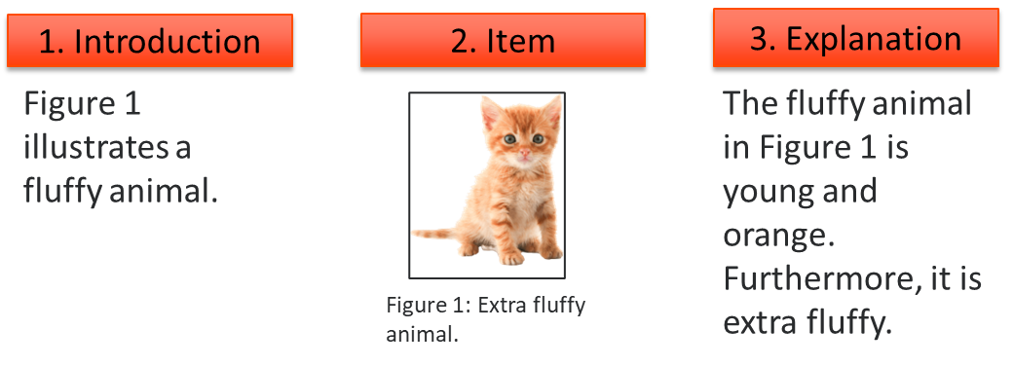

Using Appendices

If an item you want to present does not nicely fit within the text or is larger than half a page, it should be in the appendices. These items could include images, diagrams, code examples, test results or similar. Furthermore, material that provides additional information about the project such as a user manual could be placed in the appendices.

* You may try to resize large items, but make sure the content does not get blurry and the font sizes are large enough to read.
* The content of your report is more important than the length. Do not be afraid of "losing pages”. Use the appendices when you need to.
* The appendices have their own numbering, and the names of the appendices must be manually updated to the table of contents.

Examples of fitting a visual item on a single page:

Good:

Not good:

